Sam Lee

2/18/18

EEE 117L

Professor Rudametkin

Pre-Lab 3: Oscilloscope

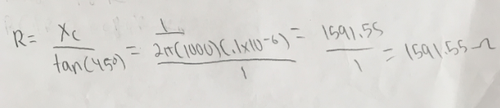

**Part I Vertical Controls:**

|  |  |  |  |  |
| --- | --- | --- | --- | --- |
| Circuit Element | Specified Value | Measured Value | Percent Error | Observations |
| R1 |  |  |  |  |
| R2 |  |  |  |  |
| C |  |  |  |  |
| Vin(x1) |  |  |  |  |
| Vout(x1) |  |  |  |  |
| Vin(x10) |  |  |  |  |
| Vout(x10) |  |  |  |  |
| Vin(x100) |  |  |  |  |
| Vout(x100) |  |  |  |  |

**Part II Triggering Controls:**

|  |  |
| --- | --- |
| Observe when | Observations |
| Trigger level changes |  |
| Toggled from + to - |  |
| Toggled from “AUTO” to “NORM” (Within the signal Voltage) |  |
| Toggled from “Auto” to “NORM” (Outside the signal voltage) |  |

**Part III Measurements**

|  |  |  |  |  |  |  |
| --- | --- | --- | --- | --- | --- | --- |
| Element | Voltage | Frequency | Time Delay | Period | Phase Shift | Magnitude |
| RMS wave 1 (measured) |  |  |  |  |  |  |
| RMS wave 1 (calculated) |  |  |  |  |  |  |
| RMS wave 2 (measured) |  |  |  |  |  |  |
| RMS wave 2 (calculated) |  |  |  |  |  |  |
| RMS Wave 3 (measured) – Ch 1 |  |  |  |  |  |  |
| RMS Wave 3  (calculated) – Ch 1 |  |  |  |  |  |  |
| RMS Wave 3 (measured) – Ch 2 |  |  |  |  |  |  |
| RMS Wave 3  (calculated) – Ch 2 |  |  |  |  |  |  |

Signature:

S. Aguilar Rudametkin